MINISTRY OF GENERAL EDUCATION
I/SCIENCE LESSON PLAN
NAME OF TEACHER:________________________ SCHOOL:_____________________
GRADE | TOPIC | SUB TOPIC | DURATION | DATE
9 | LIGHT AND ITS NATURE | Uses of converging and diverging lenses | ____min | ____/___/__
ATTENDANCE: Boys:______ Girls:_______ Total:_____
TEACHING/ LEARNING AIDS : Models, Chalk board, Learners books and Charts.
REFERENCES : I/Science Progress book 9, Study kit I/Science Pamphlet
RATIONALE: This is lesson number two on Light and Nature in the series of three. It will help learners acquire skills and values of the uses of different types of lenses. Group work, discussion, demonstration and Question & Answer methods will be used to execute the lesson.
PRE-REQUISITE SKILLS/ KNOWLEDGE: learners have prior knowledge on the Light.
SPECIFIC OUTCOMES, LSBAT:
- Explain the mechanism of a converging lens to produce real and virtue images
- Explain the uses of converging and diverging lenses
- Draw the location of the focal point and focal length of a lens
STAGE | CONTENT | TEACHERS ACTIVITY | PUPILS ACTIVITY | METHODS
INTRODUCTION  ____min | Recap on previous lesson  The different types of lenses  A Converging lens is also known as a convex lens. It is thicker in the middle and thinner at the edges. It makes parallel light rays passing through it to bend inwards and meet (converge) at a point.  Converging lens  Concave lens | Teacher asks random questions to find out what they can recall | Pupils answer and participate during the lesson | Brainstorm
D  E  V  E  L  O  P  M  E  N  T  ___min | The mechanism of a converging lens to produce real and virtue images?  Object outside focal point  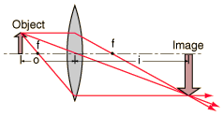  Focal length  - - A real image is the image formed where the light rays are focused. Real images occur when objects are placed outside the focal length of a converging lens or outside the focal length of a converging mirror.  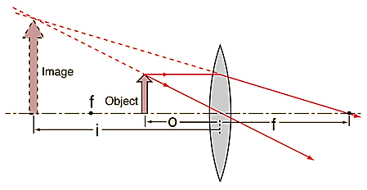  Virtual image  Focal length  Object inside focal point  - - A virtual image is formed at a location from where light rays appear to have converged. Converging lenses form virtue images if the object distance is shorter than the focal length.  The uses of converging and diverging lenses  Converging and diverging lenses are used in:  - a microscope  - a magnifying Glass  - camera film projector  - Spectacles. | Teacher explains the details to the learners  Real image  Teacher puts pupils in groups to discuss  Teacher writes brief notes on the board | Pupils listen and ask questions  Pupils discuss and bring out points  Pupils copy the notes in their note books | Teachers  Exposition  Group  work  Individual work
PRACTICAL ACTIVITIES
- Explain the mechanism of a converging lens to produce real and virtue images
TEACHER/ PUPIL’S EVALUATION………………………………………………………

